Integration

**Integration between Workday, Azure APIM and Power Apps**

**Integration between the Workday, Azure APIM and Power Apps Custom Connector**

1. **Workday API (Application Programming Interfaces) developer should develop the Workday API.**
2. **After that API should have to deploy into the Azure APIM.**
3. **Power Apps Custom Connector will be called the Azure APIM.**

**Integration Diagram:**

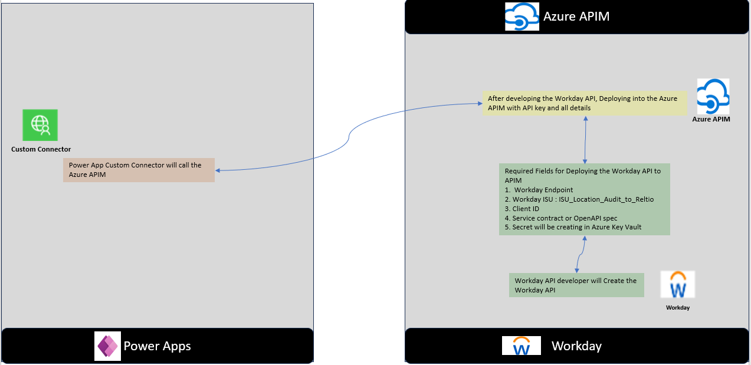

**Fig: Integration between the Workday, Azure APIM and Power Apps**

**Detail Explanation:**

1. **Workday API Developer:**

Workday developers should develop the Workday API for Creation of Cost Centers using this API.

1. **Deploying Workday API into the Azure APIM**

If the Workday user wants to store the Workday API in Azure APIM, then the Azure APIM team is expecting the below details from the Workday API user.

**Required Fields for Deploying the Workday API to APIM**  
1. Workday Endpoint

2. Workday ISU: ISU_Location_Audit_to_Reltio

3. Client ID

4. Service contract or OpenAPI spec

5. Secret will be creating in Azure Key Vault

Once the above details are available then Azure APIM team can deploy the Workday API in Azure APIM and they will publish that APIM.

1. **Power Apps Custom Connector will call the Azure APIM**

Consuming the Azure APIM to the Power Apps using the following steps.

The Power App team is expecting the below details from the Azure APIM team.

Here for Creation of Custom Connector from Scratch, Power App team should have to follow 6 steps.

1. **General**

**Name:** Workday APIM Connector

**Description:** Custom Connector to integrate the Workday API via Azure APIM

**Host:** This value is expecting from the Azure APIM team. For ex: “**apim-host.azure-api.net**”

**Base URL:** /workday

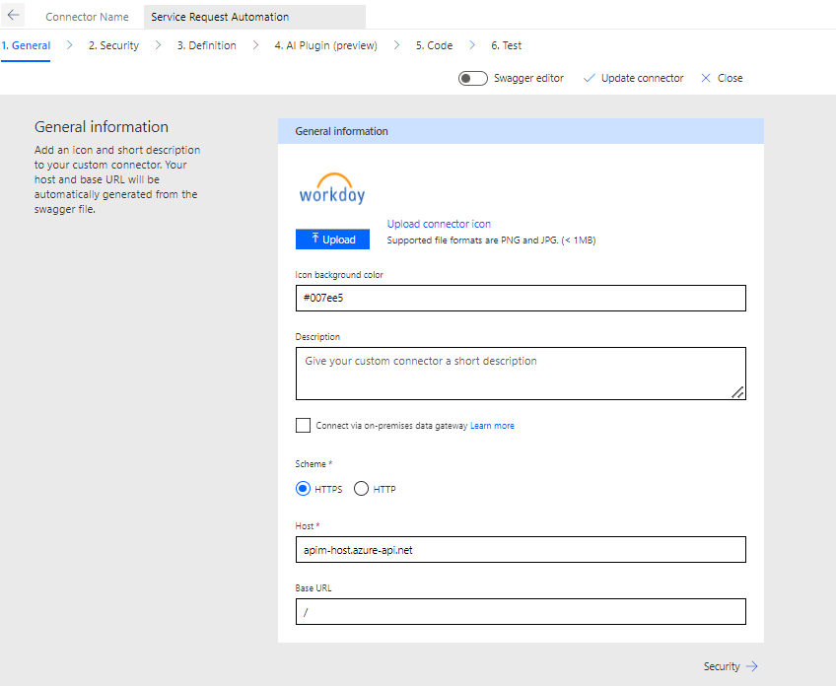

**Fig: General step in Power Apps Custom Connector**

1. **Security**

Configure the security settings to use an API Key.

**Authentication Type:** API Key

**Parameter Label:** API Key

**Parameter Name:** This is also required from Azure APIM team. For ex: Ocp-Apim-Subscription-Key (The name required from APIM team)

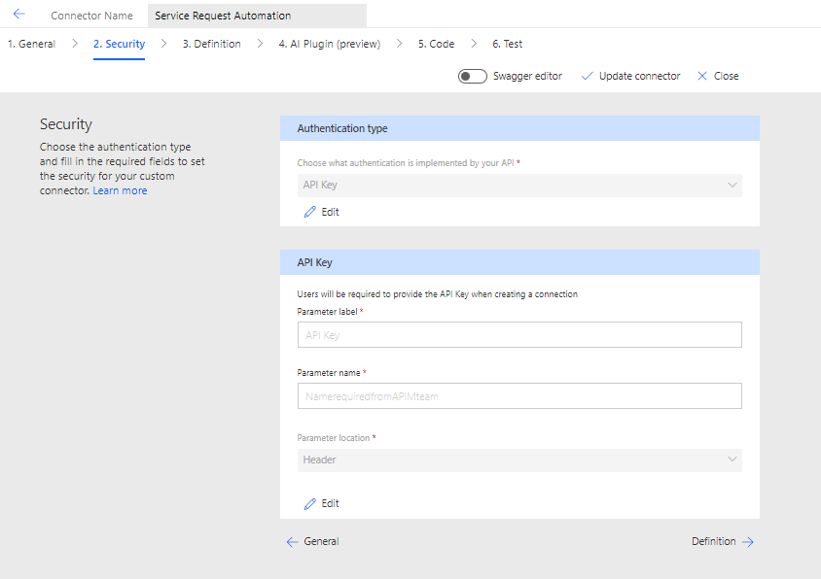

**Fig: Security step in Power Apps Custom Connector**

1. **Definition**

**Define actions for obtaining the token and Creating the Cost Centers.**

**Action1: Get the Initial Bearer Token**

**Summary:** Retrieve the Initial Bearer Token.

**Operational ID**: getInitialBearerToken

**Request:**

* **Verb**: POST
* **URL:** /oauth2/token
* **Headers:**

{

“Content-Type”: “application/x-www-form-urlendcoded”,

“Ocp-Apim-Subscription-Key”: “{{api_key}}”

}

**Body:**

{

“grant-type”: “client_credentials”,

“client_id”: “{{client_id}}”,

“client_secret”: “{{client_secret}}”

}

**Response:**

{

“access_token”: “string”,

“token_type”: “string”,

“expires_in”: “integer”

}

**Action2: Get the second Bearer Token**

**Summary:** Retrieve the second Bearer Token.

**Operational ID**: getSecondBearerToken

**Request:**

* **Verb**: POST
* **URL: /**apim/endpoint
* **Headers:** {

“Authorization”: “{{initial_bearer_token}}”,

“Content-Type”: “application/json”,

“Ocp-Apim-Subscription-Key”: “{{api_key}}”

}

**Body:** Define the body based on APIM requirements

{

“grant-type”: “client_credentials”,

“client_id”: “{{client_id}}”,

“client_secret”: “{{client_secret}}”

}

**Response:**

{

“access_token”: “string”,

“token_type”: “string”,

“expires_in”: “integer”

}

**Action3: Create Cost Center**

**Summary:** Create a new Cost Center in the Workday.

**Operational ID**: CreateCostCenter

**Request:**

* **Verb**: POST
* **URL:** /workday/costcenters
* **Headers:** {

“Authorization”: “Bearer {{initial_bearer_token}}”,

“X-Workday-Auth”: “{{second_bearer_token}}”,

“Content-Type”: “application/x-www-form-urlendcoded”,

“Ocp-Apim-Subscription-Key”: “{{api_key}}”

}

**Body:**

{

"cost_center_name": "{{cost_center_name}}",

"code": "{{code}}",

"reorganization": "{{reorganization}}",

"visibility": "{{visibility}}",

"include_code_in_name": "{{include_code_in_name}",

"subtype": "{{subtype}}",

"refrence_Id": "{{reference_id}}",

"include_organization": "{{include_organization}}"

}

**Response:**

{

“status”: “success”,

“message”: “cost center created successfully”,

“cost_center_id”: “string”

}

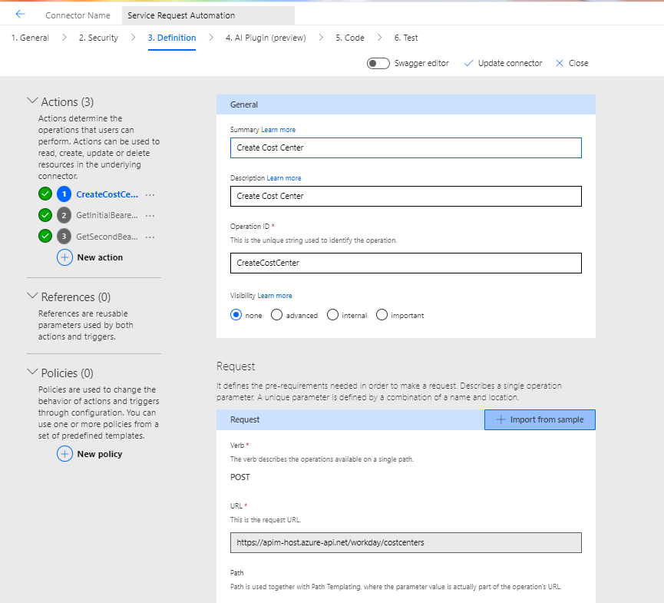

**Fig: Definition step in Power Apps Custom Connector**